The Parish of St Matthew’s and
St Luke’s, Oxford
The shared vision of our churches (2026)

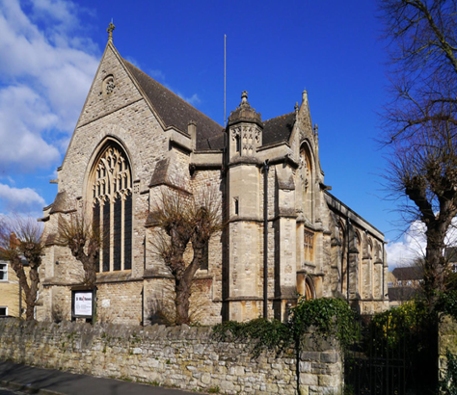 | 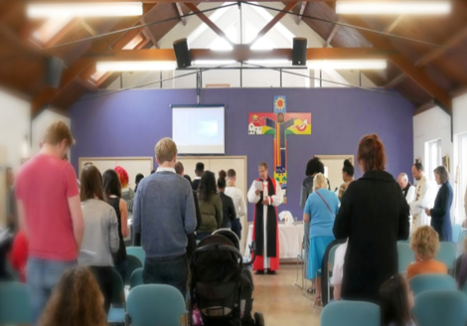

Introduction
This vision document describes the passion for ministry, the gifts and the callings which are already in action in our churches. We continue to pray that we will build on these gifts and callings that are so evident among us and that God will enable our ministries and churches to thrive.
This document also includes reflections on the St Matthew’s Vision statement in 2021 and outlines how the areas of focused action that were set out have grown and developed. This renewed vision for both St Matthew’s and St Luke’s is based on our shared understanding and gratitude for what God is providing for us and a desire to understand where he is leading us.
It is important to us that all members of our congregations, including our young people, contribute to this Vision. We believe we all have something to offer. We have prayed and worshipped together at our Away Day in October 2025; there have been discussions at PCC and DCC meetings; we are having ongoing conversations with church members including the young people; we seek God’s guidance through collective and private prayer. This has all contributed to compiling this document and ensuring many voices are heard.

The three relationship strands

“A three-strand cord is not easily broken” Ecclesiastes 4.12
This symbol of unity and strength remains at the heart of our vision. So the three-strand cord of Ecclesiastes would look like this for St Matthew’s and St Luke’s:
“To love and worship God, to love our neighbours as ourselves, through growing together in Jesus”

St Matthew’s in its own words (from the Parish Profile 2019)
- We are a community of people seeking to know and love God, and to grow in this love and knowledge through life’s experiences. We value acceptance and hospitality and welcome all, seeking to be intergenerational in our approach. We believe Christian faith is relevant to our daily lives. We seek to express it in creative ways and to encourage others on their journey with Christ. The church is involved in the community through a range of activities.
St Luke’s in its own words (from www.stlukesoxford.org.uk)
- LOVE IN ACTION. We look for practical ways to care for one another, our neighbourhood and for our world. We work for peace and reconciliation, and challenge injustice where we see it. We express faith in a way that does not hide from life’s difficulties. We share food, fun, creativity and the arts. We look for the transforming power of the Holy Spirit in our lives. At a recent away day we summarised our vision: To worship God, grow in the Spirit, share the good news about Jesus, and serve the community.

Helping ministries and callings to begin, grow and thrive

Our walk with Jesus is at the heart of all we do. Our core purpose is to build up our Christian lives and help each other for living out that life in our homes, neighbourhoods, workplaces and schools. Our church members continue to have lots of good ideas about what could happen and how we can grow, building on the many good things already happening in our day-to-day life together. In setting out this vision we want to celebrate all that we already have in our life together and also name certain areas where we believe we should focus our attention for the next few years. In this way we seek to enable growth.
Through prayerfully seeking God’s help and guidance we are proposing four areas of focus, building on what we have already been doing. We want to support and enable people who have a heart for these priorities to get involved, to recognise and express their calling to ministry in its fullness. We also want to discover and celebrate new possibilities brought by new voices.
We want to encourage everyone to continue praying. Discerning our way forward was possible as we prayed and worshipped together at our joint Away Day and in prayer meetings. The more time we spend praying, together and in our personal devotions, the more we will hear the mind of the Lord.

Areas for Focus in 2026 and going forward

- Building our life of faith. This will include exploring new ways of worship and prayer and helping people to develop and grow in their ministries and callings. There have been many developments in our worship together over the last few years which we can build upon such as Sustain, Messy Church, Soul Space and regular evening services at St Matthew’s.

- Growing the Church and building on connections with people of all ages. This focus will build on successful community engagement in the last few years and a belief that we are at the heart of our neighbourhoods. We are ready to focus on more targeted pioneer outreach. This includes continuing to get to know young adults locally, inviting children and families into our churches and reaching out to older people.

- Environmental and social justice. We have made progress in reducing the carbon footprint of our buildings and will continue to do so through the Refresh Project in the Parish Centre at St Matthew’s. We want to build on this and work for environmental justice. We also want to continue to work for social justice through how we give our money to mission partners and how we get involved in equality and justice issues. We also offer hospitality to our growing fellowship of congregations.
- We want to put our values into practice, focussing on a golden thread of diversity and inclusion in all we do.
Making this happen
The PCC and DCCs will be a focal point for discussion and planning but everyone in our churches can be involved in bringing this vision to life and in prayer.
Task 1: audit: what is going on already which can be built on?
Task 2: pray and seek the Lord for guidance on what we do first within these areas of focus. Also encourage people with a heart for this work to pray and consider how they can get involved.
Task 3: Decide on actions. We hope that this will be a mix of ‘quick wins’ that we can do immediately and longer-term goal which will take a while to build and mature. We will work together across our two congregations and separately when this is more appropriate.
Communication
- Clarify the roles of the PCC and DCC in decision making and receiving reports and make this known.
- Regularly inform the church members on what is going on and how to be involved. Use the newsletter, notices, word of mouth and after-service information sessions
- Keep our neighbours and others informed and engaged through St Matthnews and our websites
- Have themed services and prayer meetings
- Once a year Away Days to worship, pray and seek guidance

Finally

All of this will take prayer, time and money. We have confidence that if God is leading our vision he will also bless us with the resources we need to deliver it. Delivering our vision will need all of us, individually and together, to pray and to seek God’s guidance about how he wants us to invest our time, talents and tithes (another unbreakable three-stranded cord!).

For Prayer and Reflection

What are the gifts and skills the Lord has given you?
What are you passionate about in the church’s mission?
How can you help?

Appendix: Building on our Vision from 2021
The areas we focussed on in the 2021 Vision are listed below, with just a few highlights to report on the difference that focus made:
- Environmental and social justice
- Mission giving includes social action e.g. CAP, Semiliki Trust, Faith in Government
- Reduction in carbon footprint in Church
- Refresh Project to install lower carbon heating in the Parish Centre
- Local community engagement
- Passion Play
- Regular events for the community – Garden Party, Carol Singing, Fire Pit
- Engagement with neighbours in planning the Refresh Project and fundraising.
- Art workshops at St Luke’s
- Diversify the profile of the congregation
- Pioneer outreach with young adults
- Monthly Older People group
- Develop our children’s work with local families
  - Employment of Youth and Children/families workers
  - Messy Church
  - Be Space

