Cycling
to
St Matthew’s
We have received the go-ahead from the Diocese of Oxford to replace the existing butterfly-shaped cycle hoops with new cycle stands.
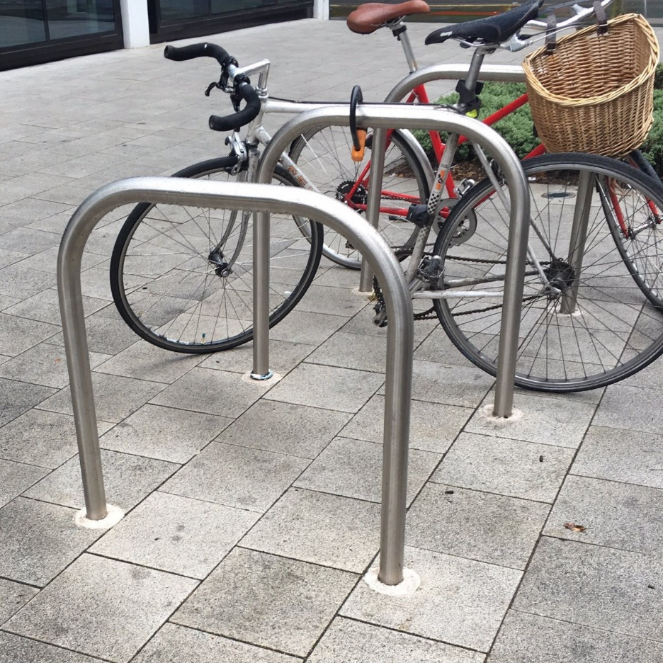
Now we need to select the exact design. The Buildings Committee has reviewed the stands available, and proposes to purchase the widely used “Sheffield” design.
The Sheffield bike stand allows for the secure locking of two cycles, one on either side.
The stands come in a wide range of colours. We propose a stainless steel finish.
If you have any comments on the proposed choice of stands please let us know, by Friday 16th July.

Chris Taft, Churchwarden Alice Boughton, Deputy Churchwarden

